**Universal DLL – user manual**

The universal DLL is meant to be used with OMDAQ3 to command a motorized stage with up to 6 degrees of freedom of motion (up to 3 of linear motion and up to 3 of rotary motion). The motors that are responsible for the motion of the platform must be stepping motors and their control is made with the aid of a Nano Arduino. More details on the control and the communication with the Nano Arduino are given below.

1. **Parameters**

Figure 1 - Window launched when OMDAQ3 is executed to set the parameters of the motorized stage. This example has the necessary parameters to command a stage that can move along 2 linear axes, with a step of 2.54 µm along each axis. Notice that the steps are indicated in mm, so this is the unit in which the positions will be displayed in OMDAQ3.

When OMDAQ3 is launched and links successfully with the DLL a window such as the one that is displayed in figure 1 pops up in the screen. Through this window the user provides the parameters to communicate with the stage’s controller (“COM”, “Baud” and “Mode”) and indicates the step size of each axis available for motion. If an axis is available, the corresponding step is provided. If not, just write any word, such as “missing” (you should not however just leave it blank, as that will cause an error!). This will inform OMDAQ of the degrees of freedom of motion of the stage and an appropriate stage control panel (figure 2) will appear in the main window of the program. Note that OMDAQ is not prepared for a stage that does not have motion along the 3 Cartesian axes and therefore these axes will always be displayed in the control panel (the unused axis position cannot be changed and is always the same, usually 0). In the parameters window (figure 1) X, Y and Z identify (as usual) the axis of linear motion. Rot1, rot2 and rot3 identify the rotation axis.

**Please make sure that the step provided for each axis coincides with the step of the stepping motor that performs the motion. Incorrect values will result in a mismatch between the position of the stage and the position perceived in OMDAQ and possibly damage to the stage if hardware limits are inadvertently breached.**

**1.1 Communication parameters**

The first 3 parameters on the window displayed in figure 1 are meant to open the communications channel with the Nano Arduino. The “COM” number is the only parameter that the user may have to change since the opened COM door may change every time that the USB cable is reconnected to the PC. To check which “COM” door was opened go to *Device Manager->USB Controllers.*

“Baud” and “Mode” are parameters to set up the RS232 protocol. The Baud rate defines the speed with which the information is exchanged, in bits per second. 9600 is a common value. The mode “8N1” is the most usual and it means 8 bits, no parity, 1 stop bit. The values provided in figure 1 for these 2 parameters (which are the default values) are the appropriate ones to communicate with the Nano Arduino.

**1.2 Position units**

The units that OMDAQ displays for the position of the stage along one axis (figure 2) is set by the units used for the “step” parameter provided for that axis (figure 1). The set of parameters shown in figure 1 configure a stage that can move along 2 linear axes, with a step of 2.54 µm along each axis. Each step is provided not in µm but in mm, and therefore the positions will be displayed in mm on OMDAQ3 (figure 2).

The standard units (that is, the units that OMDAQ3 expects) for the linear position axis are mm and for the rotation axis are degrees (º). The user is free to use other units but must be careful that OMDAQ3 will always inform that the positions are in millimeters and the angles in degrees and that can be misleading and lead to the breach of hardware limits which will result in damage of the stage.

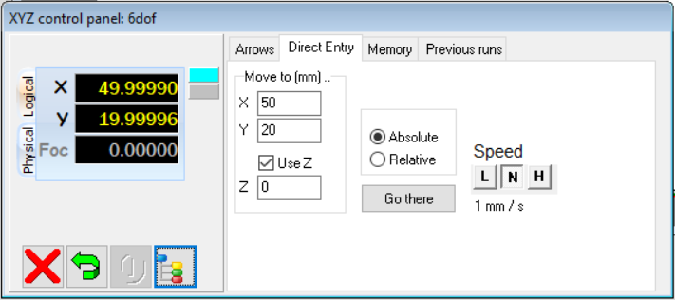

Figure 2 - Stage control panel that shows the stage position. According to the degrees of freedom of the stage more information can be shown in this panel, namely regarding the angles. This is the displayed control panel for the parameters shown in figure 1 (two translation axis). The positions are displayed in mm since this was the unit used for the “step” parameters. The unused axis Z always displays 0.

1. **Communication with Nano Arduino**

Each order of motion that is sent from OMDAQ3 to the Nano Arduino is a string. Each axis that is added to the stage in the parameters window corresponds to 2 more numbers that are added to such string. For each axis are assigned 2 numbers:

* the number with the direction of motion, 0 or 1. The number 0 corresponds to motion in the negative direction and 1 to motion in the positive direction.**\*\*\*** (see end of document for important information about the direction of motion of the stage in OMDAQ3)
* the number with the number of steps required to perform a certain motion (obtained from the “step” parameter provided in the parameters window, figure 1, and the position required by the user).

Examples:

* For the stage whose parameters are provided in figure 1 a motion of 25.4 µm along X (in the positive direction) would be ordered as: “1 10 0 0\n”.
* For a stage with all 6 degrees of freedom a motion of 10 steps along the first rotation axis (in the positive direction) would be ordered as “0 0 0 0 0 0 1 10 0 0 0 0\n”
* For the same stage with the 6 degrees of freedom a motion of 10 steps along all the Cartesian axis (in the positive direction) would be ordered as “1 10 1 10 1 10 0 0 0 0 0 0\n”

The order in which the axis appear on the string is the same as the order in which they are presented on the parameters window (figure 1), counting downward. Only the **available** axes will have two numbers assigned in the order of motion. If all 6 degrees of freedom are available, the string sent has the format below, where the subscript “d” represents the direction number and the subscript “s” the number of steps.

* “Xd Xs Yd Ys Zd Zs Rot1d Rot1s Rot2d Rot2s Rot3d Rot3s\n”

1. **Using the DLL**
   1. **Motion**

The user can require a move through the stage control panel, shown in figure 2. This panel will change according to the degrees of freedom of the stage, showing the positions of all the existing axis. For each position required the motor will move to approximate that position as close as possible (due to the discrete motion of stepping motors). It will approximate the required position minimizing the gap between the demand and the actual physical position, either approximating it by defect or by excess. For example, with a step of 0.5 mm, starting on the position 0, the demanded position of 29.3 mm will actually correspond to the physical position of 29.5 mm. The demanded position of 29.2 mm will correspond to the physical position of 29 mm.

**3.2 Programmed runs**

OMDAQ-3 allows sequences of sample stage positions and analysis conditions to be saved and executed as a batch process. This translates to the automation of an experimental procedure. All the details on how to setup a sequence of programmed runs are given in the document “Programmed run sequences in OMDAQ.pdf”, which is present in the OMDAQ-3 installation folder, under the subfolder “Documentation/Programmed run sequences in OMDAQ”. More details about Programmed runs are also available through the help file of OMDAQ-3, available under the main menu of the program.

**\*\*\***Please note that OMDAQ3 makes a distinction between physical and logical coordinates. The coordinates seen by the user in the data acquisition system are the logical coordinates. By default, the logical x and y coordinates are the physical x and y coordinates multiplied by -1, while the remaining coordinates (z and angles) are the same. Therefore, if the logical x is 50 the physical x is minus 50 (-50), and the same with the y axis. This can generate some confusion since, if the conversion between the logical and physical coordinates is not changed, “logical motions” in the positive x or y direction will actually be physical motions in the negative x or y direction, and vice-versa. To change this, go to the “Settings” button in the stage panel (figure 2, fourth button to the right in the bottom left), go to *Coordinate transformations->Internal* and set the angles under “Linear axis transformation angles” so that the physical and logical axis are the same. This means changing the entry in the row “Motor1” and column “X” from 180 to 0 and changing the entry in the row “Motor2” and column “Y” from 180 to 0. The desired settings are shown in figure 3.

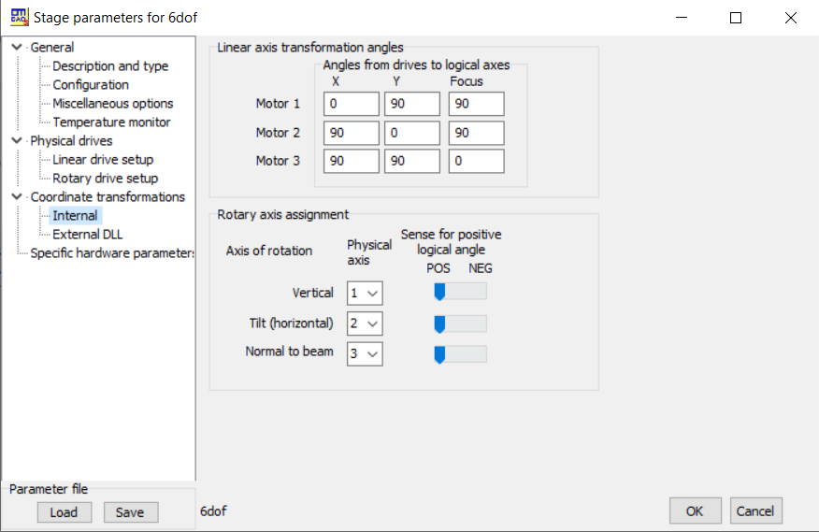

Figure 3 – Settings so that physical and logical coordinates are the same in OMDAQ3.